# Running an Antivirus Scan

This document will explain how to check your workstation for viruses using Trend Micro, which is Premier’s antivirus software.

1. Open the System Tray on your Desktop.

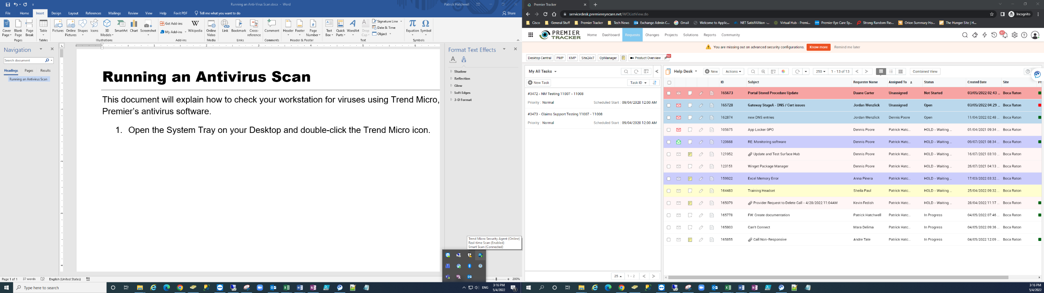

1. Double-click the **Trend Micro icon**.
2. This will open up Trend. Click on **Scan**.

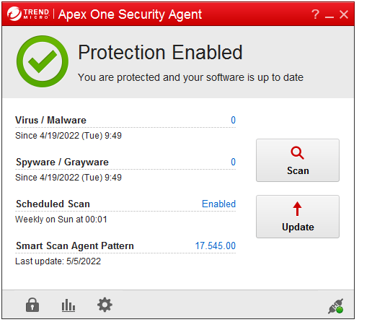

1. **1.** Click inside the **My Computer checkbox** to select everything. **2.** Click **Scan**.

**1.**

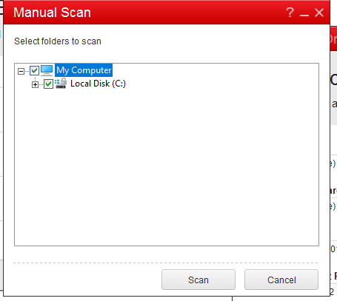

**2.**

1. 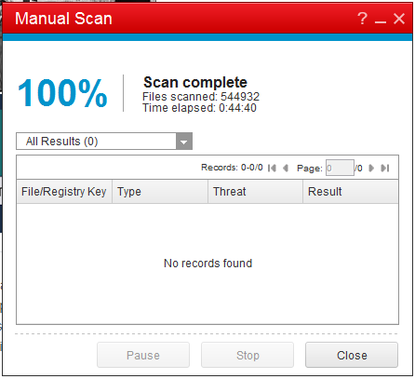You can minimize the window while it scans and keep working. When it is done, you will see 100% and Scan Complete. Trend will let you know if anything was removed or if you got a clean scan.