# Using Proofpoint

Proofpoint is the program used by Premier for:

1. Sending encrypted email.
2. Blocking junk mail/spam.

Proofpoint is an add-on in Outlook. This document will walk you through using all the features in Proofpoint such as:

* + **Sending an encrypted email**
  + **Using the digest email**
  + **Blacklisting/whitelisting email**

## Send an Encrypted Email

1. To send an encrypted email, open **Outlook**, and click the **New Email button**.

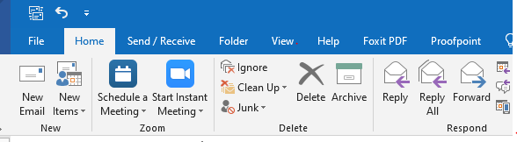

1. When you are ready to send your email, click the **Send Securely Encryption button**.

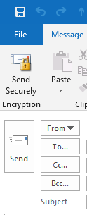

## Use the Digest Email

You receive three daily **End User Digest** emails around midnight, noon, and 4 pm in your Outlook Inbox. The End User Digest email lists emails sent to your Quarantine folder by Proofpoint.

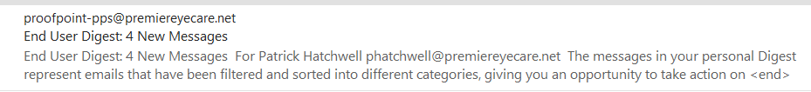

The End User Digest email allows you release valid emails from quarantine by performing one of the actions below by clicking on the **hyperlink**.

1. **Release:** Delivers the email to your Inbox but does not White List the sender.
2. **Release and Allow Sender**: Delivers the email to your Inbox and allows future emails from that sender to go to your inbox folder instead of your quarantine folder.
3. 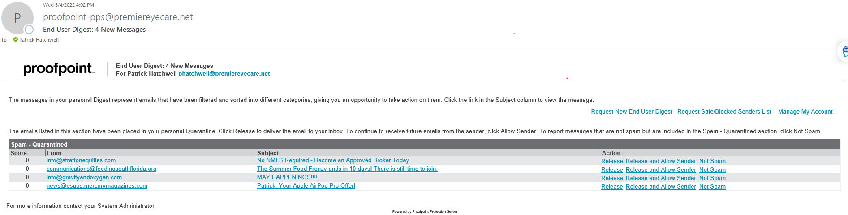**Not Spam**: Reports messages that were sent to the Spam folder as Not Spam.

The instructions are right in the email in case you forget. If they are spam and they should stay in quarantine, you don’t have to do anything.

### Resending the End User Digest

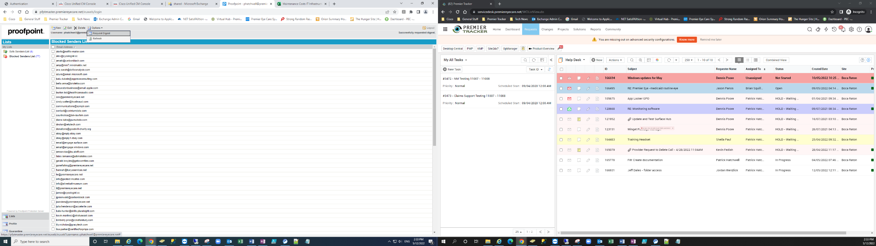If for some reason you need to resend yourself the End User Digest, you can do so from within Proofpoint, under the Options Menu. This will send a list if all emails. The digest sent during the day is incremental from the last digest that was sent. If you don’t get a digest, this means that no new spam is being held by Proofpoint since the last digest.

## Blacklist/Whitelist Email

**Backlisting** is when you block or flag an email, domain, or sender as spam. **Whitelisting** is when a valid email, domain, or sender is flagged as spam and you want Proofpoint to allow it through.

### Blacklist an Email that is in your Inbox

You can blacklist an email in your inbox by **dragging it to the Proofpoint quarantine folder**. Do not use the quarantine folder under Spam.

☑

🗵

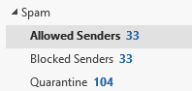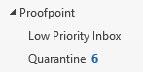

If you click on the **Proofpoint top folder**, you will see more instructions on using Proofpoint.

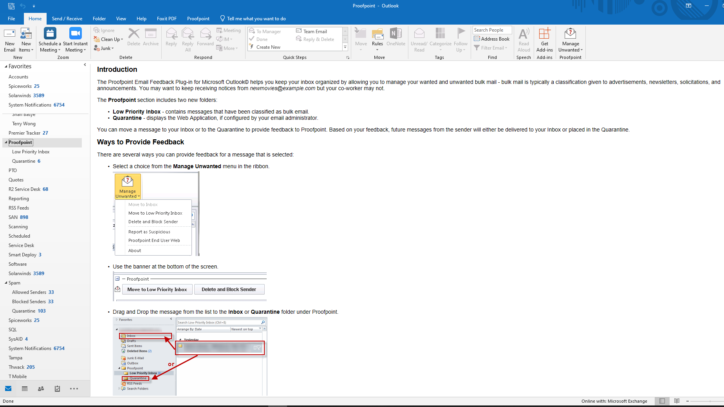

When you drag an email to or click on the Low Priority Inbox folder, you see emails that are flagged as Low Priority, meaning that you don’t want them cluttering your regular Inbox and will look at them in the Low Priority Inbox.

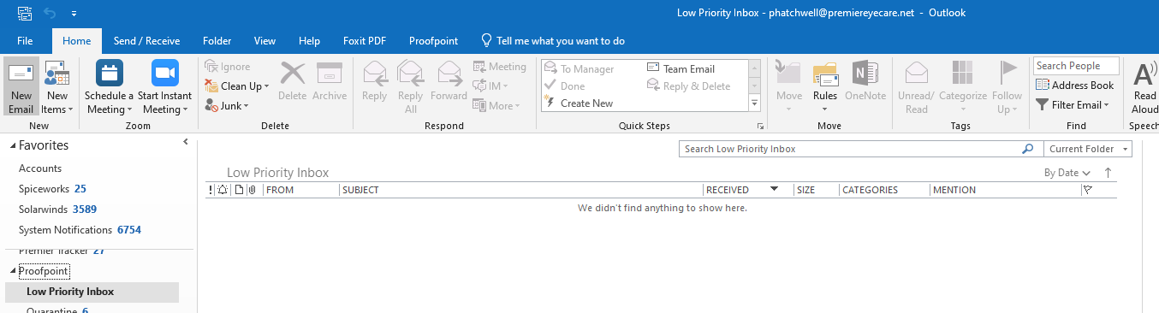

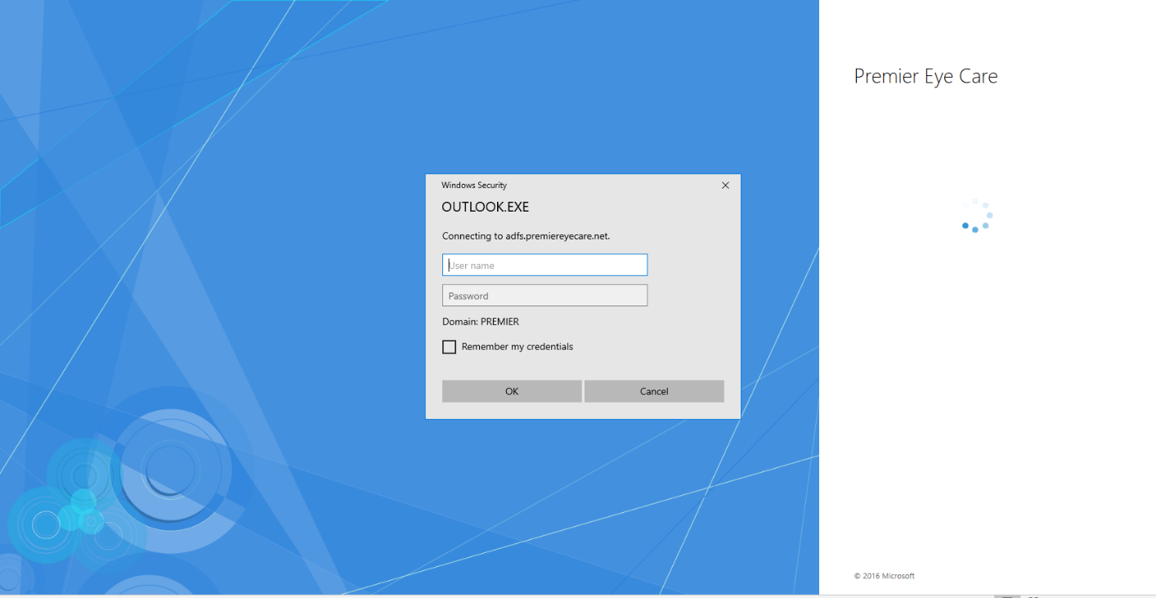When you drag an email to or click on the **Quarantine folder**, you will be taken to the **Proofpoint Application**, and will have to enter your email credentials.

You can also click on the **Manage Unwanted Proofpoint** icon from your button bar. This will take you to the Proofpoint End User Web app.

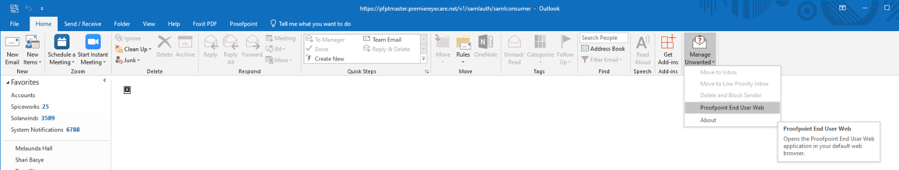

After you enter your credentials, you will see the Proofpoint dashboard and can blacklist (Blocked Senders List) or whitelist (Safe Senders List)

### Whitelist an Email or Domain

When you go through the End User Digest, you are looking at blacklisted (blocked) emails that you might want to whitelist (allow). If you want to add an email address of a domain, go directly to the **Safe Senders List**.

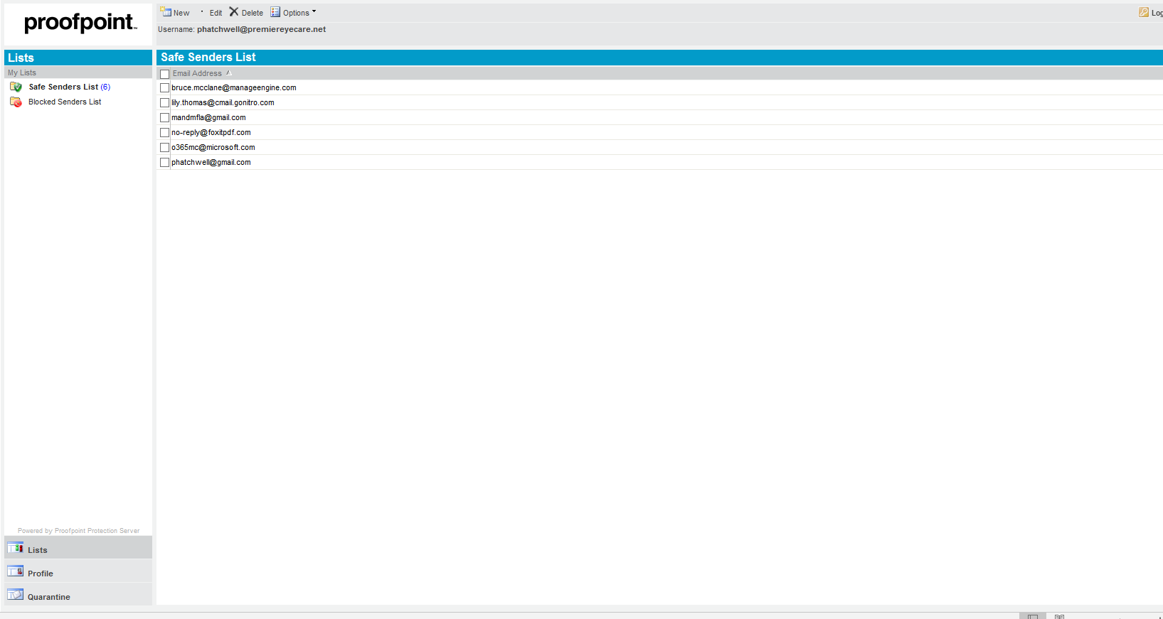

Click on the **New button**, to add a specific email. If you type in a domain, all emails from that domain are allowed to your inbox.

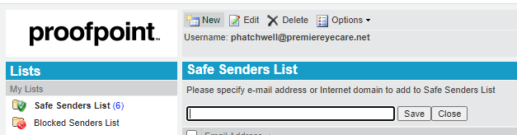

You can also click on the checkbox next to an item, and click either the **Edit** or **Delete** item button.

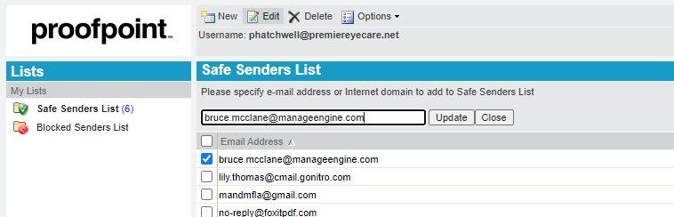

### Blacklist an Email or Domain

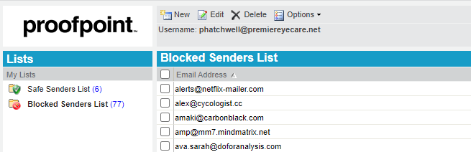

Blacklisting is done through the **Block Senders List** and is the exact same, except that you are blocking rather than allowing.

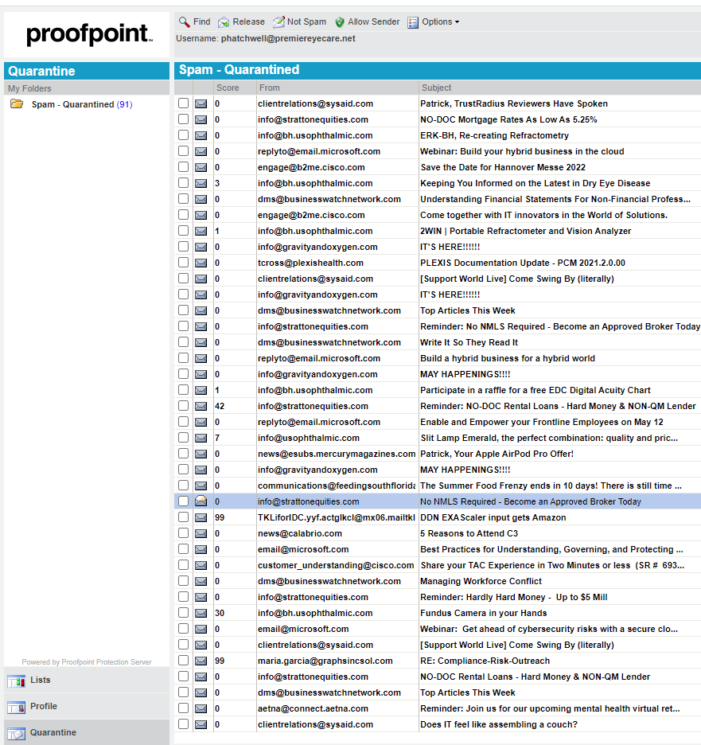

### Unquarantine an Item

If you accidentally blacklist an item by sending it to Quarantine, you can always click on the **Quarantine link**, find the blocked email and release that specific email or mark it as not spam, meaning that emails from that address will come through to your Inbox in the future.

If you still have questions or need assistance, please send an email to [HelpDesk@premiereyecare.net](mailto:HelpDesk@premiereyecare.net).